**Assignment 2**

Task-1: Create your First page using the HTML structure.

<html>

    <head>

        <title>

            Welcome Page

        </title>

    </head>

    <body>

            the content you want to display on the page

            Pictures

            Links

            Videos

            Audios

            Animation

            Game

            Form

            <br>

            This is my first html page

    </body>

</html>

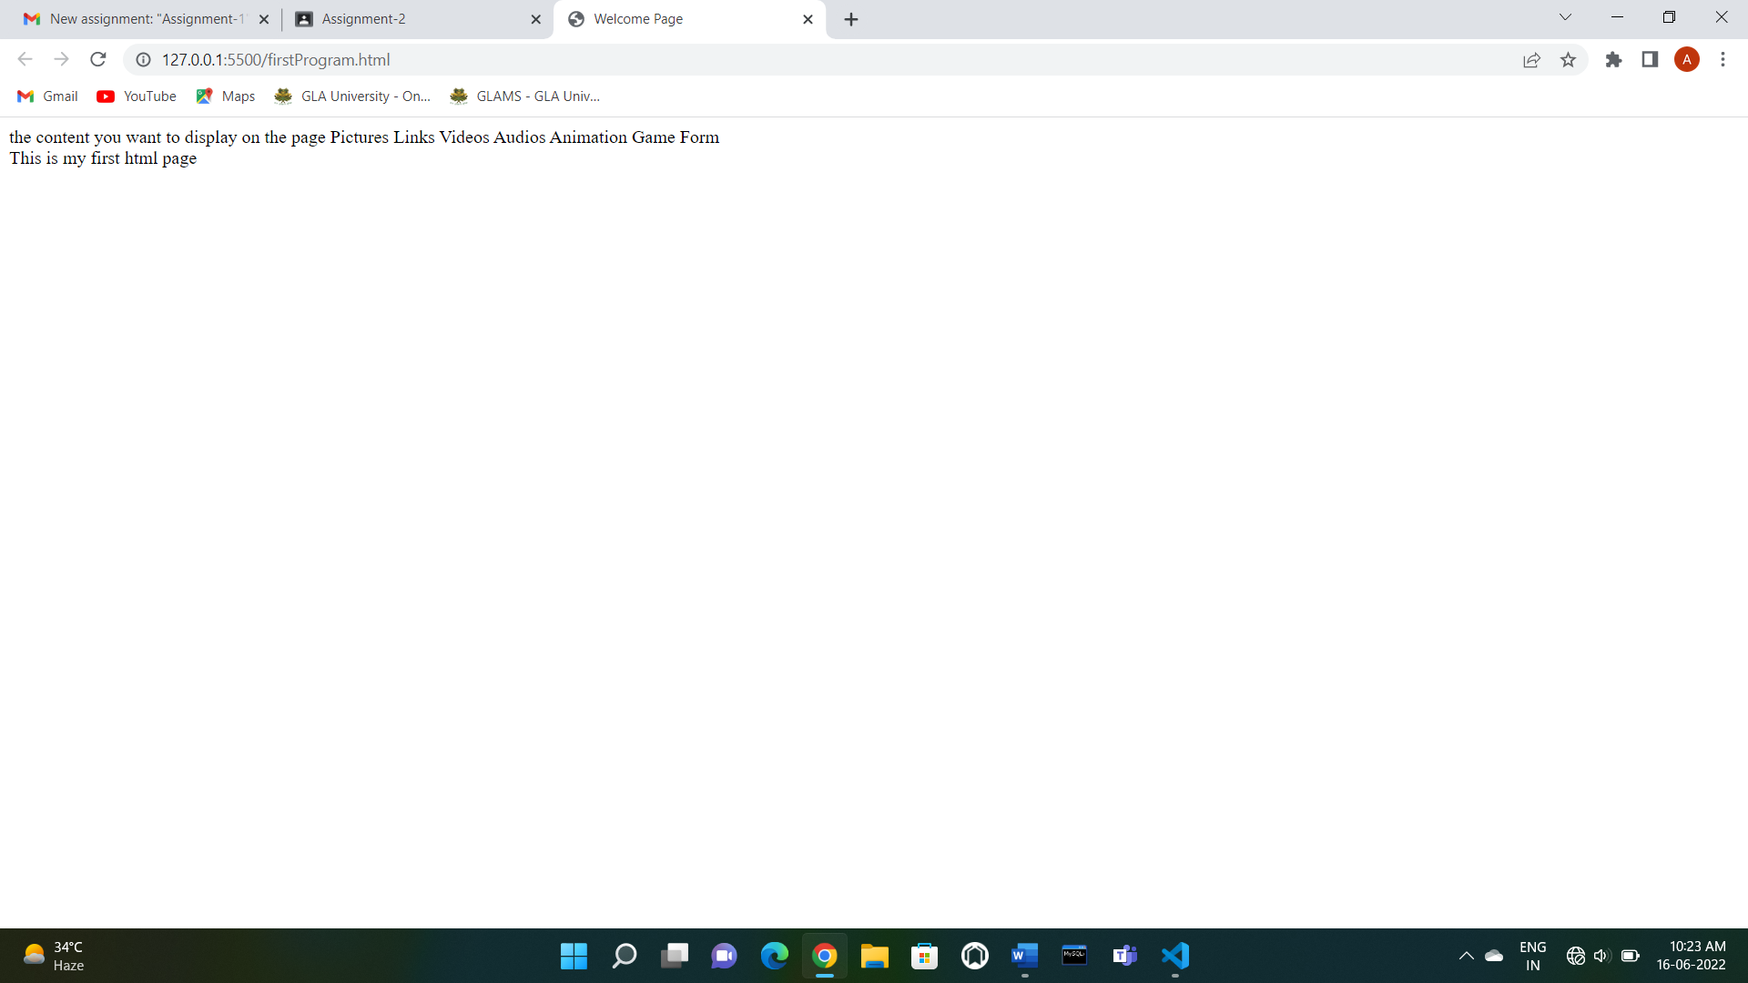

Task-2: Create your Second page using VSCode Snippet.

<!DOCTYPE html>

<html lang="en">

<head>

    <meta charset="UTF-8">

    <meta http-equiv="X-UA-Compatible" content="IE=edge">

    <meta name="viewport" content="width=device-width, initial-scale=1.0">

    <title>Second Page</title>

</head>

<body>

    this is my Second page.

</body>

</html>

